Assessment Parameters

- Solution Completeness (including all requirements addressed) – 30%
- The appropriate usage of required templates – 10%
- Preparing Use Cases, identifying & categorizing the requirements, writing appropriate test cases for each requirement –60 %

Instructions:

Q1. Go through the following “Issue Tracking System” scenario carefully and complete
the below given tasks.
- Identify and categories the requirements involved in the given scenario using Requirement Itemization Template.
Marks Distribution: [20 Marks]
Criterion | Marks
- Identifying all types of requirements from the given case study i.e. requirements related to security, explicit, implicit, application invocation, application termination, file handling, error handling & system rquirements.  - Identifying queries relevant to the application & requirements given in the case study. | 5
- Writing good, clear and effective requirements keeping in mind the characteristics of good requirements discussed in the class.  - Defining suitable level of priority for the requirements  - Right usage of requirement itemization template. | 15

Q2. Write Use Case for “Raise Ticket” business functionality from the given case study.
Refer to the Figure 1.3 & Business Rules table for the same.

Marks Distribution: [20 Marks]
Criterion | Marks
The use cases should adhere to the following:  - Correct and defect free usage of the use case template  - Identification of correct actors involved in the use case  - Proper naming convention should be followed for use case names  - Identifying all applicable Preconditions as per the scenario  - Determining the correct Basic Flow and Alternate Flows  - Mentioning precise Post Condition  - Identifying all applicable success and failure scenarios  - Identifying use case assumptions (If required) | 20

- Only employees of the company can raise ticket by using the Issue Tracking System.
- The employee should have valid Username and Password to login to Issue Tracking System

NOTE – Apart from IT Infrastructure Management, all other functions are out of scope
Raise New Ticket and the Home links are within the scope

Step 1: Employee can raise a ticket by visiting the URL https:\\its.servicedesk.com directly
through Internet browser.
Following login page will be displayed after invoking the application.
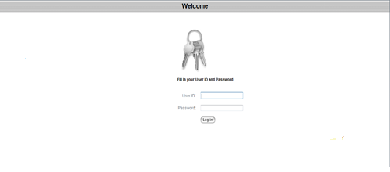
Figure 1.1
Employee can login with the application using valid domain user name and password. If user enters invalid username and password, then the appropriate error message should be displayed to the user as: “The system could not log you in. Please make sure your username and password are correct.” After successful login the following page will be displayed.
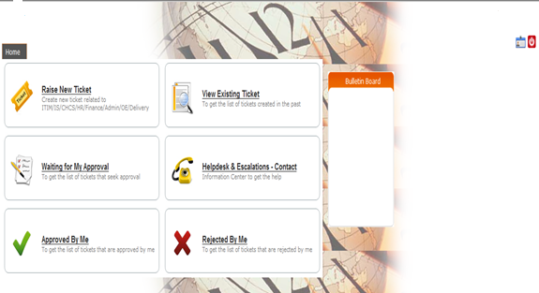
Figure 1.2

Step 2 : The employee need to click on the “Raise New Ticket” to raise a new ticket
The following form will be displayed upon selecting “Raise New Ticket”
option
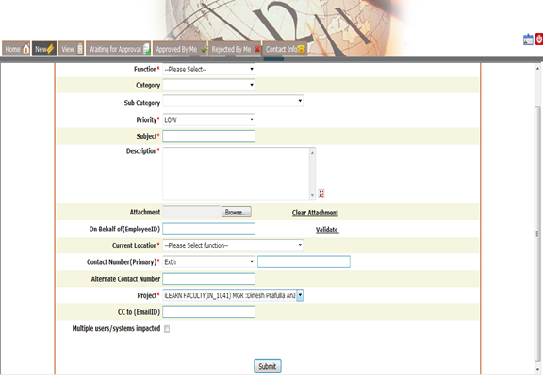
Figure 1.3
Step 3: The employee need to fill the form with the appropriate details and click the
“Submit” button to raise the ticket. The ticket should be raised successfully if an
employee provides all valid data while raising the ticket. A unique ticket number
should be generated once the ticket has been raised successfully by the employee. An
autogenerated notification email should be sent to employee’s manager to seek
approval on ticket raised by the employee to process the ticket.

Business Rules:
- All fields with (*) are mandatory fields
- The valid categories are as follows
  - Laptop/Desktop
  - Mail
  - Software
- Once the employee selects the desired Category, the Sub Category dropdown should be populated.
- The valid values for Sub Categories are as follows
  - Laptop/Desktop
    - Laptop/Desktop Issues
    - Admin Rights
  - Mail
    - Mail Issues
    - Mail Forwarding
  - Software
    - Approved software installation
    - Software Issues
    - Software Uninstallation
- The valid values for Priority field are LOW, MEDIUM and HIGH
- An employee can share the error screenshot files or other documents while raising the ticket
- The application can accept only files with .jpg, .gif and .doc extension
- The employee can remove attachement by clicking on “Clear Attachment” link
- The application should ask for user confirmation before removing an attachement while raising the ticket
- An employee can raise a ticket on behalf of some other employee in thr organization
- The value of this field should be different from the Employee ID of the employee raising the ticket
- This can be checked by clicking on the “Validate” link and appropriate error message should be displayed to the user in case of failure
- If employee selects Extension as Contact Number then the value should not be more than 4 digits
- If employee selects Mobile No as Contact Number then the value should not be more than 10 digits
- Current Location field should contain valid company locations
- Alternate Contact Number should be a valid Mobile No consisting 10 digits only
- CC to field should accept valid email id having igate.com as a domain name

Q3. Write test cases for the “Raise New Ticket” web page to validate the user entries
with the help of given requirements.
Refer to the Figure 1.3 & Business Rules for the same.

Marks Distribution: [20 Marks]

Criterion | Marks
The test cases should adhere to the following:  - Identifying positive, negative and relevant test cases from the given case study  - Participant need to write at least TWENTY test cases  - Assumptions (if applicable) for the test cases should be written properly  - The test case id should be written in correct format  - The applicable preconditions for the specific test case should be mentioned in clear and thoughtful manner  - The test condition should be precise and written in proper format  - The test steps & the corresponding test data for the test steps should be written correctly  - The expected result should be written appropriately as per the test steps written for the test case | 20

Criterion | Marks
- The participant need to make the entry in Defect Tracking Sheet for all the defects identified  - Every negative test case written can be used as a base for writing defects in the Defect Tracking Sheet  - Participant need to write at least FIVE defects in the Defect Tracking Sheet | 5
The defects logged in the defect tracking sheet should adhere to the  following:  - Every defect should have a unique Defect ID associated with it  - The Defect ID should follow the valid format as per the guidelines  - The appropriate value for the Module Name field should be written  - The Defect Summary & Defect Description should be written with lot of caution and as per the guidelines, tips and tricks of writing defect free defect report discussed during the class  - The Defect Severity and Defect Priority should be defined appropriately  - The status of the defect should be given appropriately  - All other columns/fields of Defect Tracking Sheet should be filled appropriately based on the guidelines discussed during the class | 5

Following are the software and hardware related requirements that needs to be taken care by the user while accessing the web site.

- Software Requirements:

Type of Software | Supported Version
Operating System | • Microsoft Windows XP SP2 Professional  • Microsoft Windows XP SP3 Professional  • Microsoft Vista (32-bit or 64-bit)  • Microsoft Vista SP1 (32-bit or 64-bit)  • Windows 7 (32-bit or 64-bit)
JRE | • Java 6 Update 10 or higher
Web Browser For Windows |  | • Internet Explorer 8  • Internet Explorer 9  • Internet Explorer 10  • FireFox 10 ESR  • FireFox 12 or higher  • Chrome

- Hardware Requirements
  - 800 MHz or higher
  - 256 MB RAM or higher & System should be enabled for audio and video

